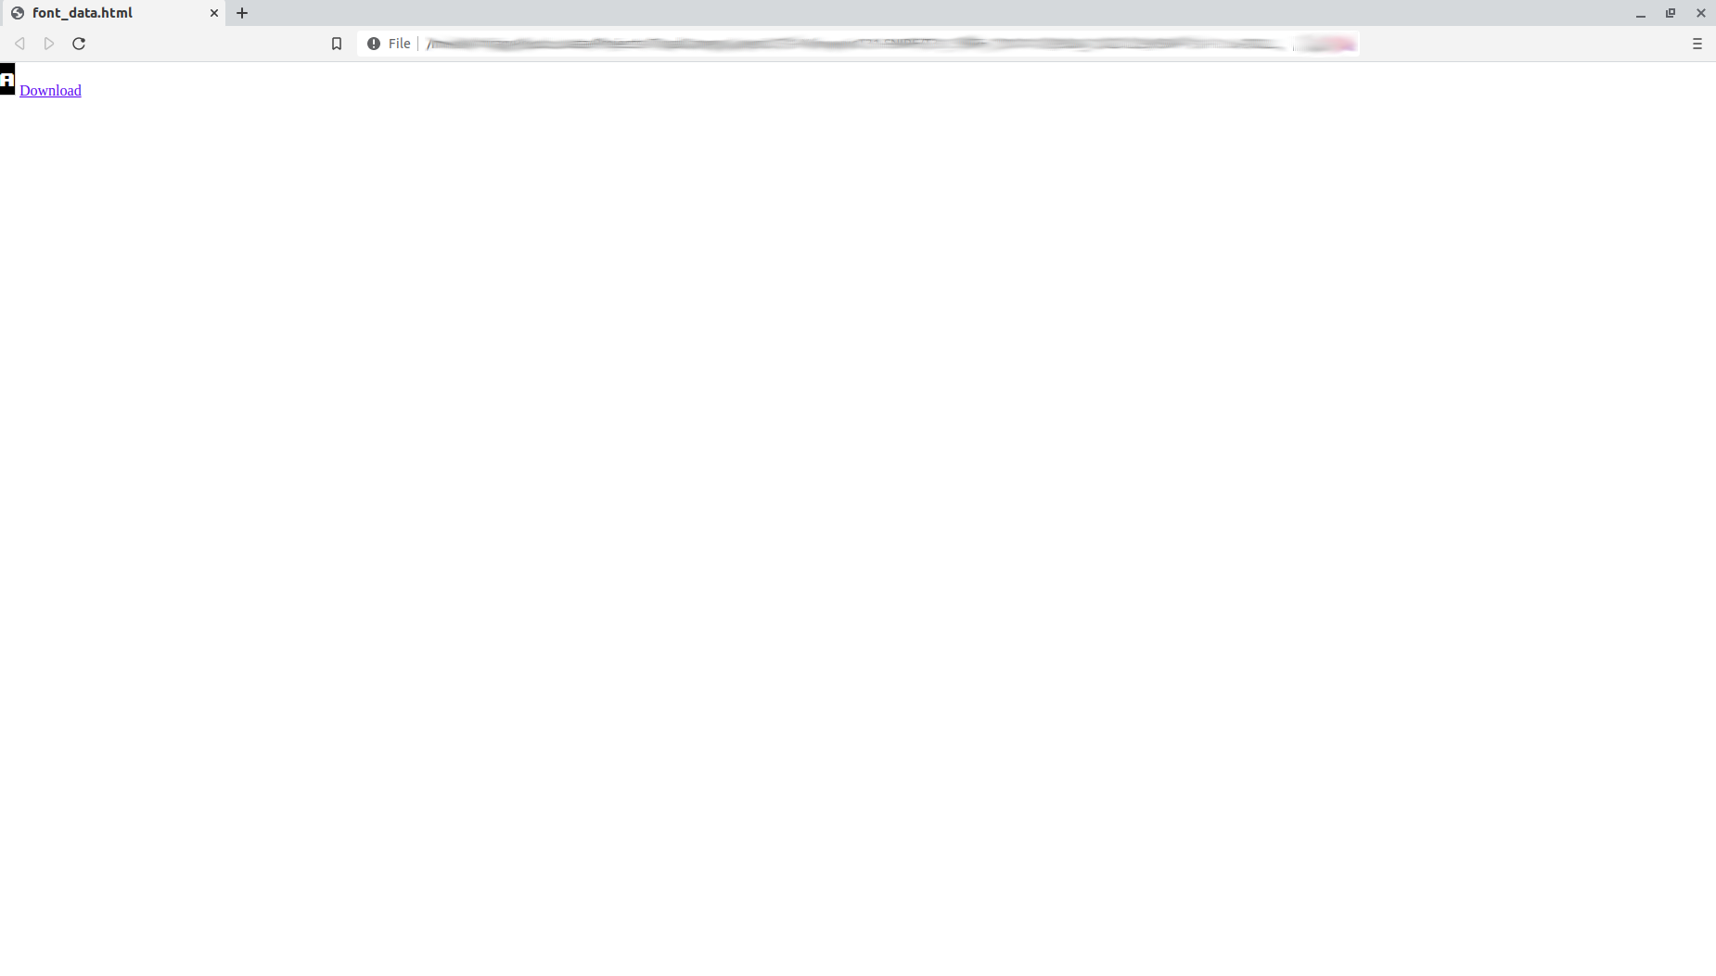

**Functionality Explanation:**

1. Create a 16x34 px canvas.

2. Write any char of any font family center of the canvas.

3. Keep any font color except black.

4. As shown in the above image, create a download link using anchor tag.

5. When a user clicks on download, download a file which contains canvas region pixel color data in hex format.

6. Below is the output of a sample download file. Also attached output file for reference.

